Tab 1

From Volunteer to Vocation: The Career Impact of Skill and Network Development in a Global Tech Nonprofit

ABSTRACT
Remote skill-based volunteering (SBV) represents an understudied context for training and development, yet its potential as a structured learning environment remains empirically underexplored. This study examines how participation in a globally distributed medical AI nonprofit shapes career outcomes for volunteers. Using a mixed-methods design, we surveyed 1,280 volunteers, yielding 78 complete quantitative responses and 47 qualitative narratives. Structural Equation Modeling confirmed construct validity (CFI = .994, SRMR = .032), while Relative Importance Analysis (LMG method) resolved high predictor multicollinearity (r = .865), explaining 57.5% of variance in career outcomes. Contrary to expectation, leadership and communication skills, not technical competencies, emerged as the strongest career predictors, and network quality consistently mattered more than network size. Thematic analysis corroborated these patterns across six inductively derived themes. We report a Cross-Training Effect: technical volunteers gained disproportionate returns from leadership development, while non-technical volunteers benefited most from technical skill acquisition. These findings suggest that remote SBV may function as a leadership development accelerator, and that structuring volunteer programs around leadership opportunity and quality mentorship, rather than task execution alone, may optimize career returns.
Keywords: Skill-Based Volunteering, Human Capital, Social Capital, Career Development, Remote Volunteering, Mixed Methods

1. INTRODUCTION
The landscape of professional development is shifting as remote work becomes standard in the global economy (Autor, 2014; Deming, 2017; Raghuram et al., 2001). Against this backdrop, virtual skill-based volunteering (SBV) positions have emerged as a unique opportunity to gain relevant skills for career progression (Caligiuri et al., 2013; Steimel, 2018; Wilson, 2000). While traditional volunteering is characterized by general service tasks such as event organization or community outreach, SBV involves individuals contributing specialized professional expertise to support an organization's mission (Steimel, 2018). A critical gap, however, exists in our understanding of this phenomenon. Volunteering has been well studied from a psychological standpoint, with an extensive body of literature exploring the motivations to volunteer, focusing largely on altruism, social values, and personal well-being (Wilson, 2000), but empirical research surrounding its tangible career outcomes remains sparse.
Our study addresses this gap through a mixed-methods analysis of the relationship between remote SBV and career development. The studied nonprofit operates entirely remotely and provides a setting to examine two forms of capital: Human Capital, the acquisition of technical and interpersonal skills (Becker, 1964; Autor, 2014), and Social Capital, the professional networks through which individuals access opportunity (Bourdieu, 1986; Coleman, 1988). Together, these frameworks provide the theoretical lens to examine what volunteers gain and why it matters.
We argue that remote nonprofits function as cross-training environments. In these resource-constrained settings, volunteers face startup-like conditions requiring high levels of initiative and self-regulation (Baruch, 2000; Raghuram et al., 2001). Drawing on survey data from 78 volunteers, our analysis finds that while Leadership and Communication skills are the most influential factors for the sample as a whole (R² = .575), we identify what we term a Cross-Training Effect, to our knowledge, the first empirical documentation of this pattern in the SBV literature, whereby technical volunteers derive their greatest returns from leadership capabilities, whereas non-technical professionals gain disproportionate value from technical skill acquisition. These preliminary findings offer an empirical starting point for bridging the gap between traditional training and the demands of the future workforce (Autor, 2014; Deming, 2017).

2. LITERATURE REVIEW

2.1 Theoretical Framework: Human and Social Capital in Digital Nonprofits
This study utilizes Human Capital and Social Capital theories to evaluate how skill-based volunteering (SBV) facilitates career advancement in distributed contexts. Human Capital theory (Becker, 1964) suggests that individuals enhance their labor market value by investing in specific proficiencies. In a technology-mediated environment, this includes hard technical skills alongside soft interpersonal capabilities like leadership and time management (Autor, 2014; Deming, 2017).
Social Capital theory (Bourdieu, 1986) complements this by focusing on the resources embedded within professional networks. In remote nonprofits, volunteers collaborate across geographic boundaries, facilitating weak ties. Weak ties are essential for career development as they provide access to non-redundant information and professional opportunities that are typically unavailable in more homogeneous local networks (Burt, 2004; Coleman, 1988; Granovetter, 1973).

2.2 Cultivating "T-Shaped" Professionals through Remote Collaboration
Modern engineering education and management research increasingly emphasize the need for T-shaped professionals. These are individuals who possess deep, specialized expertise in a specific domain, but also exhibit the broad collaborative and integrative capabilities necessary to solve problems across disciplines (Bredillet, 2010; Oskam, 2009; Patel & Mehta, 2017).
In the context of digital-first, resource-constrained nonprofit organizations, volunteers are often exposed to startup-like conditions that necessitate wearing multiple hats. They must coordinate across distributed teams and take initiative in unfamiliar areas. We hypothesize that such environments naturally cultivate this combination of deep expertise and cross-disciplinary collaboration. By simultaneously developing specialized technical skills and transferable leadership capabilities, SBV enhances a volunteer's overall competitiveness in the modern labor market.

2.3 Skill-Based Volunteering as a Cross-Training Environment
Traditional volunteering is often characterized by general service tasks, such as organizing events, fundraising, or community service. In contrast, SBV involves individuals contributing specialized professional expertise to support a nonprofit's mission (Steimel, 2018). These contributions may include technical skills, such as software development and cloud infrastructure management, as well as professional services like legal counsel, marketing strategy, or project management. Unlike general volunteering, SBV tasks are directly tied to organizational outcomes and often resemble the types of work in paid professional roles (Steimel, 2018; Caligiuri et al., 2013).
The Functional Approach to volunteerism (Clary et al., 1998) identifies career advancement as one of six motivational functions behind volunteering. SBV aligns with this function by its very nature; it provides a structured environment in which participants can gain experience, develop new competencies, and demonstrate their abilities in real-world projects. Research indicates that SBV is particularly attractive to two groups: students seeking to bridge the gap between academic knowledge and professional practice, and mid-career professionals leveraging SBV to develop skills outside their current job domain, creating a form of experiential cross-training that broadens expertise and enhances career flexibility (Steimel, 2018; Caligiuri et al., 2013).
Moreover, SBV offers opportunities for accelerated role expansion, problem-solving in complex organizational contexts, and exposure to diverse teams, all of which contribute not only to technical skill acquisition but also to the development of transferable soft skills such as leadership, communication, and project management. In this way, SBV operates not only as a volunteer activity but as a strategic career development pathway, providing tangible opportunities to accumulate both human and social capital while contributing to meaningful organizational outcomes. In training and development terms, this positions SBV as a structured non-formal learning environment (Marsick & Watkins, 1990), where competency development occurs through authentic participation in consequential work tasks rather than through formal training programmes. The career returns observed in settings like this are consistent with evidence that informal learning embedded in authentic work-based contexts yields meaningful and durable competency gains (Plasman, 2023) Indeed, research suggests that informal and non-formal learning pathways account for a substantial proportion of workplace skill development, yet remain undertheorized relative to their contribution (Smith, 2023)
The distributed nature of remote SBV adds a further dimension to this development. The shift toward remote work has introduced new competency requirements where success depends on self-regulation and the ability to coordinate without physical co-location (Raghuram et al., 2001; Piccoli et al., 2004). In the absence of direct supervision, competencies such as self-discipline, asynchronous communication, and time management become critical professional assets in their own right (Baruch, 2000). This study therefore, posits that the remote nature of the studied organization is not merely logistical but a core component of Human Capital development, uniquely shaping the acquisition of competencies that are increasingly valued in contemporary labor markets (Raghuram et al., 2001; Baruch, 2000).

2.4 Research Gap and Hypotheses
Despite the rapid growth of the digital nonprofit sector, few studies have quantitatively examined the return on investment (ROI) for volunteers themselves. First, Relative Importance: it remains unclear whether career advancement is driven more by the acquisition of technical skills or by the development of leadership and managerial experience. Second, Subgroup Heterogeneity: it is unknown whether technical and non-technical volunteers derive the same types of career benefits, or whether participation produces a differential Cross-Training Effect, allowing volunteers to acquire skills outside their primary domain. Existing research on SBV underscores its potential as a career development pathway (Steimel, 2018), but empirical evidence demonstrating the realization of these outcomes remains limited (Caligiuri et al., 2013).
By applying the rigorous statistical techniques of Structural Equation Modeling (SEM) and Relative Importance Analysis (RIA) to survey data from a digital-first nonprofit, this study allows for a systematic identification of the distinct drivers of professional advancement. In doing so, it examines how remote SBV contributes to the accumulation of Human Capital (technical and interpersonal skills) and Social Capital (network expansion), and how these forms of capital translate into observable career outcomes.

3. METHODOLOGY

3.1 Research Context
The study was conducted within a US-headquartered nonprofit organization developing smartphone-based AI tools for respiratory disease screening. The organization operates with no physical offices, relying entirely on digital collaboration infrastructure, and its volunteer workforce spans multiple continents with professionals at many career stages, from high school students to professors and senior industry professionals. This organizational model provides a uniquely rich context for examining SBV’s career outcomes.

3.2 Participants and Data Collection
An online survey was distributed via email invitation to the organization's complete list of past and present volunteers (N = 1,280). All 78 respondents who consented provided complete responses on the core evaluation items (response rate = 6.1%), yielding a final analytic sample of n = 78. The 12-item survey instrument (see Appendix A) was developed using 5-point Likert scales (1 = “Strongly Disagree” to 5 = “Strongly Agree”) to measure three latent constructs. Note that survey items are labeled q1–q12 by their sequential position within the Academic Research Questions section of the survey instrument (corresponding to items 6-17 in the full survey).
- Human Capital (Skills): Four items measuring self-reported growth in Technical Skills (q1), Communication Skills (q2), Leadership Skills (q3), and Time Management (q4).
- Social Capital (Network): Three items measuring Network Size (q5), Network Quality (q6), and Access to New Professional Communities (q7).
- Career & Academic Outcomes: Five items measuring Résumé Competitiveness (q8, q9), Success in Securing a Job or Academic Placement (q10), Advancement into Leadership Roles (q11), and a retrospective pre-post growth magnitude item (q12: “Compared to before you joined, to what extent did your skills improve?”) measuring perceived growth. Although q12 was retained in the survey instrument as a descriptive growth indicator, it was excluded from the SEM and RIA analyses, which focused on the four behaviorally-anchored outcome items (q8-q11).

3.3 Geographic Distribution of Respondents
The demographic composition of the sample reflects the organization's global reach (see Table 1):
- Role Type: 51 participants (65.4%) held technical roles (Machine Learning, Cloud Engineering, Web Development); 27 (34.6%) held operational roles (Marketing, Legal, HR, Grants).
- Career Stage: 46 participants (59.0%) were students (undergraduate or graduate-level); 32 (41.0%) were established professionals.
- Geography: The largest geographic segments were North America (45 respondents, 57.7%), Japan (12, 15.4%), and the UAE (10, 12.8%); full country-level detail is provided in Table 1.
[Insert Table 1 about here]

3.4 Analytical Strategy
A three-stage mixed-methods research design was employed to ensure statistical rigor, address predictor collinearity, and provide interpretative depth. The qualitative strand was positioned as contextual enrichment accompanying the quantitative findings rather than as an independent analytical track, consistent with a sequential mixed-methods design (Creswell & Plano Clark, 2018).
- Stage 1: Measurement Validation (SEM): Structural Equation Modeling (SEM) was conducted using the lavaan package in R. The WLSMV (Weighted Least Squares Mean and Variance adjusted) estimator was specified to account for the ordinal nature of Likert scale data, following Beauducel and Herzberg (2006). This step established construct validity and confirmed the factor structure prior to regression-based analyses.
- Stage 2: Relative Importance Analysis (LMG): Preliminary analysis revealed a high correlation (r = .865) between Human Capital and Social Capital composite scores, indicating a level of multicollinearity that would render standard regression coefficients unstable and unreliable. To address this, Relative Importance Analysis was conducted using the Lindeman-Merenda-Gold (LMG) method (Lindeman et al., 1980) via the relaimpo package in R. The LMG method averages a variable's contribution to R² across all possible orderings of predictors, providing a stable decomposition of explained variance even under high collinearity. This technique is methodologically superior to standard stepwise regression in this context (Whittingham et al., 2006).
- Stage 3: Thematic Analysis (Qualitative): To provide qualitative context for the volunteer experience, thematic analysis was conducted on 47 volunteer responses to three open-ended survey questions following Braun and Clarke's (2006) six-phase framework, structured as follows:
  - Familiarization: All 47 open-ended responses were read in full by the second and third authors to develop a comprehensive understanding of the dataset prior to any coding.
  - Initial Coding: An inductive coding process was applied, with the second author generating preliminary codes directly from participant language without imposing a predetermined framework.
  - Searching for Themes: Preliminary codes were organized into candidate themes through iterative review, grouping related codes that reflected shared patterns across responses.
  - Reviewing Themes: Candidate themes were first reviewed against their constituent coded extracts to assess internal coherence, then reviewed against the full dataset by the co-authors to assess interpretive consistency and contextual appropriateness.
  - Defining and Naming Themes: Final themes were defined with clear inclusion criteria and documented in a formal codebook (Appendix B). Any patterns mentioned by at least 15% of respondents (n ≥ 7) were retained.
  - Producing the Report: Finalized themes were written up with illustrative participant extracts and integrated with the quantitative findings to provide a coherent mixed-methods narrative.
While co-author review was employed to mitigate interpretive bias, the absence of independent double-coding with formal inter-rater reliability statistics is acknowledged as a limitation of this study. Subgroup analyses were conducted for two stratifications: (1) Technical vs. Non-Technical role type, and (2) Student vs. Professional career stage, consistent with established qualitative rigor practices (Braun & Clarke, 2006; Lincoln & Guba, 1985).

4. RESULTS

4.1 Model Fit and Construct Validity
The SEM confirmatory factor analysis (CFA) demonstrated an excellent fit between the theoretical model and the observed data. The Comparative Fit Index (CFI = .994) substantially exceeded the conventional 0.95 threshold. While the Root Mean Square Error of Approximation (RMSEA = .097) somewhat exceeded the conventional 0.06 threshold (Hu & Bentler, 1999), simulation evidence suggests that RMSEA can be less reliable for WLSMV models with smaller samples; however, the CFI and the Standardized Root Mean Square Residual (SRMR = .032) both indicate excellent fit (Beauducel & Herzberg, 2006). These indices collectively confirm the construct validity of the survey instrument, indicating that each item reliably measured its intended latent construct. Supporting these structural findings, a preliminary Spearman correlation analysis (see Figure 1) confirms strong, positive associations across all survey items (r = .537 to .841), justifying the use of Relative Importance Analysis to appropriately partition explained variance under high collinearity.
[Insert Figure 1 about here]
To complement the global fit indices, Figure 2 presents the standardized SEM path diagram, which visualizes both the measurement model and the structural relations among latent constructs. The figure shows strong loadings across observed indicators and positive paths from Skill Development and Networking to Career Outcomes, providing construct-level support for the regression-based findings.
[Insert Figure 2 about here]

4.2 Primary Findings: Drivers of Career Success
The LMG relative importance analysis revealed that the model explains approximately 57.5% of the variance in career outcomes (R² = .575). While this suggests a strong effect size, this value may be partially inflated by common method variance inherent in concurrent self-reported data. Contrary to the expectation that Technical Skills would be the primary career driver in a technology nonprofit, Table 2 shows a markedly different pattern. Leadership and communication emerged as the strongest predictors of career outcomes, contributing 17.2% and 16.1% to R² respectively. Technical Skills ranked fourth at 14.4%, suggesting that in this context, interpersonal and coordinative capabilities may offer greater career returns than domain-specific expertise alone. Table 2 also reveals an interesting pattern within the network dimension. Network Quality, the quality of professional advice received from global peers, ranked third at 15.7%, notably higher than Network Size at 10.6%. This suggests that the depth and quality of connections formed through volunteering may matter more for career advancement than the sheer volume of new contacts accumulated.
[Insert Table 2 about here]
Figure 3 extends Table 2 by showing uncertainty around each LMG estimate, confirming that leadership, communication, and network quality remain the most influential predictors in the full sample.
[Insert Figure 3 about here]

4.3 Subgroup Analysis: The Cross-Training Effect
Decomposing the data by role type and career stage revealed significant heterogeneity in how different volunteer profiles derive career value, uncovering the Cross-Training Effect introduced in this paper: the phenomenon where volunteers gain disproportionate career returns from skills outside their primary domain of expertise (see Figure 4).
[Insert Figure 4 about here]

Finding A: Technical Volunteers: Leadership as the Missing Link
For the technical subgroup (n = 51: engineers, ML specialists, cloud architects), Leadership Skills emerged as the top predictor, accounting for 18.4% of explained variance within this subgroup (R² = .562) followed by Network Quality (16.4%).

Finding B: Non-Technical Volunteers: Technical Literacy as a Career Multiplier (Exploratory)
For non-technical volunteers (n = 27: HR, Marketing, Legal, Grants), the predictor ranking reversed sharply. Technical Skill Acquisition (q1) became the #1 career driver, accounting for 21.7% of explained variance within this subgroup (R² = .729). This finding is classified as exploratory, given the subgroup's sample size (n < 30), and should be validated in future research.

Finding C: Students: Leadership as the Primary Differentiator
For the student subgroup (n = 46), Leadership (q3) emerged as the dominant career driver (23.3%). The organization's flat hierarchy, where initiative, rather than seniority, determines leadership opportunity, allows students to acquire verifiable project leadership experience years ahead of their corporate-employed peers.

Finding D: Established Professionals: The Social Capital Premium
For the established professional subgroup (n = 32), Network Quality (q6) emerged as the primary career driver, contributing 21.5% to career outcomes. In contrast to students who prioritized leadership opportunities, professionals (who likely already possess baseline management experience) derive their greatest ROI from the “bridging” function of the organization. For this group, the value lies in high-quality professional insights and a global network of peers that transcends the siloes of their local corporate environments.
A summary of the primary career drivers and their respective R² contributions across all four subgroups is provided in Table 3.
[Insert Table 3 about here]

4.4 Qualitative Findings: Thematic Analysis
Open-ended survey responses (n = 47) were analyzed thematically to supplement the quantitative results and provide richer contextual understanding of the volunteer experience, going beyond statistical relationships to capture participants' own accounts of skill-based volunteering's role in professional development. Six major themes emerged relating to career impact; Table 4 summarizes these themes and their relative frequencies.
[Insert Table 4 about here]
Interpersonal & Communication Development emerged as the primary theme, with 64% of participants explicitly stating that they gained strong communication skills. One participant elaborated on this growth, explaining that “Many people worked on different days and time zones, so finding the overlap between us was necessary and communicating all knowledge to the team was crucial, especially in remote settings”. This emphasis suggests that communication was not simply a secondary interpersonal skill, but integral to daily task execution.
This theme was followed closely by Technical Skill Acquisition (57%). Respondents often described their work as extending their technical competencies beyond theoretical foundations into applied, professional contexts, with one describing, “I moved beyond standard app development into complex full-stack integration”.
With respect to Professional Network Expansion (55%), many respondents emphasized both the number of new contacts they formed and the quality and diversity of those connections. One respondent described how they were able to “network with and receive advice from a diverse group of professionals”.
Accounts surrounding Career Signaling and Marketability (45%) indicated that volunteering functioned as a credible professional signal, with one respondent noting, “My latest [Organization] experience is on the first page of my Resume…I always mention [Organization] when I am at clinical trials and also, when volunteering at tech conferences as part of my icebreaker and elevator pitch.”
Another mid-tier theme was Leadership and Ownership Development (36%). Participants described gaining initiative, delegation skills, and accountability for deliverables. One participant noted that they developed “a strong sense of ownership over my tasks and learned the importance of proactive communication in a volunteer team.”
Finally, while still significant, Career Identity Clarification (21%) was the least frequently cited theme. Respondents described gaining clarity about preferred industries and future goals. One volunteer explained about their work, “It gave me a sense of what kind of company and team I would want to work for moving forward. It gave me clarity on the kind of impact I want to have,” underscoring how engagement functioned not only as skill acquisition but also as a space for professional self-definition.

4.5 Converging Quantitative and Qualitative Findings
To integrate the study's findings, Table 5 presents a joint display of the quantitative and qualitative results. This triangulation reveals a high degree of convergence: Interpersonal and Communication Development, cited by 64% of respondents, aligns with Communication Skills as the second-ranked LMG predictor (16.1%); Leadership and Ownership Development (36%) converges with Leadership as the single strongest predictor overall (17.2%); and Professional Network Expansion (55%) maps onto both Network Quality and Network Access, which together account for 28.4% of explained variance. The statistical predictors of career success are thus directly corroborated by the most prevalent themes in the volunteer narratives. Furthermore, the qualitative data provide essential complementarity by capturing Career Identity Clarification, a unique dimension of professional growth that was not represented in the quantitative survey items but emerged as a significant outcome for 21% of participants.
[Insert Table 5 about here]

5. DISCUSSION
These preliminary results suggest a reevaluation of how remote SBV is positioned within the training and development landscape. While volunteering is often framed through the lens of altruism and societal contribution (Clary et al., 1998; Wilson, 2000), the data suggest these organizations also function as sophisticated non-formal learning environments (Marsick & Watkins, 1990), capable of generating substantial and structured human capital development. The most striking finding is that Leadership Skills, not technical competencies, emerged as the single strongest predictor of career advancement across the full sample (17.2% contribution to R²). This result challenges the prevailing assumption that technology nonprofits serve primarily as technical skill training grounds and suggests they may function as leadership development accelerators. In standard corporate hierarchies and university curricula, junior professionals rarely secure authentic management authority over real, consequential projects (Doh, 2003). The studied organization's flat, initiative-driven structure inverts this dynamic: a junior developer who demonstrates reliability can assume a Team Lead role within weeks, accumulating verifiable leadership experience that would otherwise require years of conventional corporate progression. The prominence of Communication Skills as the second-ranked predictor (16.1%) deepens this picture. In distributed environments where teams are not co-located, they depend more on formal communication processes and structured coordination mechanisms, making clear and deliberate communication a critical competence rather than a soft skill (Piccoli et al., 2004). Together, these two predictors account for approximately a third of the explained variance in career outcomes, consistent with broader labor market evidence that social skills command a growing wage premium (Autor, 2014; Deming, 2017). For training and development practitioners, this finding suggests that distributed volunteer programs may offer a viable non-formal pathway for developing leadership and communication competencies that are difficult to cultivate through conventional classroom-based training alone. These findings are also consistent with evidence from the training and development literature showing that leadership behaviours strengthen the relationship between informal learning and employability outcomes (van den Elsen et al., 2022), suggesting that the leadership development observed in this sample may carry meaningful long-term career implications beyond the volunteering context itself.
These quantitative patterns are corroborated and enriched by the thematic analysis. Across both strands, a consistent pattern of convergence emerges: the qualitative themes most frequently cited by volunteers correspond directly to the top-ranked quantitative predictors. This convergence between the quantitative and qualitative strands enhances confidence in the internal consistency of participants' self-reported experiences, suggesting that the patterns observed are not artifacts of a single measurement format but reflect coherent perceptions of professional growth.
The subgroup analysis reveals an equally coherent pattern: volunteers derive their greatest career returns not from deepening existing expertise, but from crossing domain boundaries. Technical volunteers benefit most from leadership exposure, which accounts for 18.4% of the explained variance within this subgroup (R² = .562), while non-technical volunteers appear to benefit most from Technical Literacy, accounting for 21.7% of their subgroup variance (R² = .729). This preliminary Cross-Training Effect is consistent with integrative talent frameworks emphasizing the value of combining deep domain expertise with adjacent competencies in complex, cross-functional environments (Oskam, 2009; Patel & Mehta, 2017). For HR managers or legal professionals, gaining exposure to technical workflows through skill-based volunteering can constitute a form of contextual competence that substantially improves their effectiveness when subsequently working within or recruiting for technology firms (Caligiuri et al., 2013). The non-technical subgroup result should nonetheless be treated as exploratory, given the limited sample size (n = 27), and warrants replication before stronger claims are made. For HR learning and development teams, this preliminary Cross-Training Effect carries a practical design implication: structuring volunteer programs to deliberately expose participants to competencies outside their primary domain, rather than simply deploying them in role-matched tasks, may constitute a form of low-cost, high-engagement cross-functional training.
A significant finding within the network dimension is that Network Quality ranked notably higher than Network Size as a career driver (15.7% vs. 10.6%). This pattern was most pronounced among established professionals (n = 32), for whom it was the single strongest predictor (21.5%), suggesting that high-quality professional advice matters more than expanding one's contact volume. These results are consistent with Social Capital Theory's emphasis on the quality rather than quantity of professional ties (Bourdieu, 1986; Coleman, 1988); for experienced volunteers, what appears to matter is not how many new connections are made, but the depth and diversity of knowledge those connections provide.
Furthermore, for professionals who already possess deep domain expertise, this experience may serve as a meaningful way to navigate complex, asynchronous professional exchanges across time zones and cultures without direct supervision (Baruch, 2000; Raghuram et al., 2001). This differentiates them from peers with similar technical backgrounds who may lack experience in globally distributed environments. For program designers, this distinction carries a clear practical implication: investing in structured mentorship and cross-functional pairing is likely to yield greater career returns than expanding volunteer numbers alone.
These findings carry direct practical implications for training and development professionals and nonprofit volunteer program designers. First, organizations should resist the temptation to deploy volunteers purely in role-matched, task-focused assignments. The data suggest that the greatest career development returns, and by extension, the most meaningful volunteer experiences, arise when participants are given genuine leadership responsibility and cross-functional exposure. Second, for HR learning and development teams seeking scalable developmental opportunities for early-career professionals, structured SBV programs may represent an underutilized training pathway: one that simultaneously builds leadership capability, asynchronous communication skills, and professional network quality at relatively low organizational cost. Third, for nonprofit volunteer program managers specifically, these findings suggest that investing in structured mentorship and cross-functional team pairing is likely to yield greater developmental returns, for volunteers and organizations alike, than simply scaling volunteer headcount. These findings extend Human Capital Theory to the distributed volunteering context, provide empirical support for Social Capital mechanisms in remote organizations, and contribute preliminary quantitative evidence to the training and development literature on the career value of combining deep expertise with cross-disciplinary capabilities in non-formal learning environments (Marsick & Watkins, 1990)

6. LIMITATIONS
This study makes a meaningful empirical contribution to the SBV literature, but several limitations constrain the strength and generalizability of its conclusions and should be acknowledged explicitly.
Sample Size and Statistical Power: The overall analytical sample (n = 78) is modest, and the subgroup analyses reduce effective sample sizes even further, most critically for non-technical volunteers (n = 27). Nevertheless, this sample size is consistent with published mixed-methods SBV studies (e.g., Caligiuri et al., 2013; Steimel, 2018) and is sufficient to support LMG decomposition with bootstrap confidence estimation. This subgroup falls below the threshold typically recommended for stable regression-based decompositions, and the associated finding (Technical Skill Acquisition contributing 21.7% to R²) is accordingly classified as exploratory. More broadly, subgroup analyses were conducted across four groups ranging from n = 27 to n = 51. While these analyses reveal suggestive patterns consistent with the Cross-Training Effect, the modest subgroup sizes limit statistical stability and all subgroup findings should be interpreted as preliminary. Future work should seek larger, more balanced samples to enable confirmatory subgroup testing and to assess whether the Cross-Training Effect holds across different organizational types and volunteer roles. Additionally, while a Shapiro-Wilk test indicated non-normality in the residuals (p < .001), this departure from normality does not invalidate the Relative Importance Analysis. The LMG method is based on the decomposition of R² rather than the distributional assumptions required for traditional frequentist inference (Lindeman et al., 1980). To ensure statistical rigor and address potential bias from non-normality or sample size, 95% bootstrap confidence intervals (1,000 resamples) were utilized for all estimates, providing a robust alternative for concluding non-normal data (Efron & Tibshirani, 1994).
Cross-Sectional Design and Causal Inference: The study employs a cross-sectional, retrospective design, meaning that all measurements were collected at a single point in time. While the retrospective pre-post growth item (q12) captures self-reported perceived growth, it does not constitute a true longitudinal or experimental design. Causal claims linking volunteer participation to career outcomes cannot be definitively established without a comparison group or longitudinal follow-up. The observed associations are consistent with a causal interpretation, but alternative explanations, for example, that more motivated individuals self-select into and sustain volunteer engagement, cannot be ruled out (Caligiuri et al., 2013). Future research should employ longitudinal designs or quasi-experimental methods to strengthen causal inference.
Survey Response and Self-Report Bias: All measures in this study were collected through a self-reported survey instrument, introducing the possibility of common method bias. Because both predictors (skill and network development) and outcomes (career advancement) were reported by the same respondents, observed correlations may be partially influenced by shared measurement context rather than fully independent effects. In addition, the survey achieved a response rate of approximately 6.1% (78 of 1,280 volunteers), raising the possibility of non-response bias if individuals who chose to respond were systematically more engaged or more satisfied with their volunteer experience than those who did not participate. The qualitative component may reflect similar bias, as only 47 respondents provided open-text responses, meaning that thematic findings likely reflect the perspectives of the more engaged portion of the sample.
Single-Coder Thematic Analysis: Although initial codes were generated by a single author, both the second and third authors participated in the familiarization phase and all candidate themes were reviewed by co-authors for interpretive consistency (see §3.4). Nevertheless, the absence of independent double-coding with formal inter-rater reliability statistics remains a limitation of the qualitative strand.
Single Organizational Context. The study is conducted on a single organization (a globally distributed medical AI nonprofit) which limits the generalizability of findings across different types of nonprofits, technology domains, geographic concentrations, and organizational cultures. The specific features of this organization (e.g., its startup-like structure, flat hierarchy, medical mission) may amplify the leadership and cross-training effects observed here. Whether these patterns replicate in more hierarchical nonprofits, domestically concentrated volunteer programs, or non-technology sectors remains an open empirical question.

7. CONCLUSION
This study examines the career return on investment of distributed skill-based volunteering within a global technology nonprofit. While methodological limitations, including cross-sectional survey design, self-report bias, and single-organization sampling, limit causal inference and generalizability, the findings provide preliminary evidence that volunteering can generate substantial professional development benefits. Contrary to expectations, leadership development, rather than technical skill acquisition, emerged as the strongest predictor of career advancement within this sample. Qualitative responses suggest that this leadership growth often occurs through ownership of deliverables, coordination responsibilities, and initiative within project teams. Additionally, this study introduces the Cross-Training Effect as an empirical contribution to the SBV literature, where volunteers derive their greatest career returns from competencies outside their primary domain: technical volunteers gained their greatest career returns from leadership development, while non-technical volunteers benefited most from technical skill acquisition. For training and development practitioners, these findings suggest that deliberately structuring volunteer programs around cross-functional exposure and genuine leadership responsibility, rather than defaulting to role-matched task execution, may represent a meaningful and scalable non-formal learning strategy. Future research should examine how SBV compares to other non-formal learning pathways in terms of competency development outcomes, and test these patterns through longitudinal, multi-organizational studies incorporating objective career outcomes to better establish causal mechanisms .
REFERENCES
Autor, D. H. (2014). Skills, education, and the rise of earnings inequality among the “other 99 percent.” Science, 344(6186), 843-851. https://doi.org/10.1126/science.1251868
Baruch, Y. (2000). Teleworking: Benefits and pitfalls as perceived by professionals and managers. New Technology, Work and Employment, 15, 34-49. https://doi.org/10.1111/1468-005X.00063
Beauducel, A., & Herzberg, P. Y. (2006). On the performance of maximum likelihood versus means and variance adjusted weighted least squares estimation in CFA. Structural Equation Modeling: A Multidisciplinary Journal, 13(2), 186-203. https://doi.org/10.1207/s15328007sem1302_2
Becker, G. S. (1964). Human capital: A theoretical and empirical analysis, with special reference to education. University of Chicago Press.
Bourdieu, P. (1986). The forms of capital. In J. G. Richardson (Ed.), Handbook of theory and research for the sociology of education (pp. 241-258). Greenwood.
Braun, V., & Clarke, V. (2006). Using thematic analysis in psychology. Qualitative Research in Psychology, 3(2), 77-101. https://doi.org/10.1191/1478088706qp063oa
Bredillet, C. (2010). Blowing hot and cold on project management. Project Management Journal, 41(3), 4-20. https://doi.org/10.1002/pmj.20179
Burt, R. S. (2004). Structural holes and good ideas. American Journal of Sociology, 110(2), 349-399. https://doi.org/10.1086/421787
Caligiuri, P., Mencin, A., & Jiang, K. (2013). Win-Win-Win: The influence of company-sponsored volunteerism programs on employees, NGOs, and business units. Personnel Psychology, 66(4), 825-860. https://doi.org/10.1111/peps.12019
Clary, E. G., Snyder, M., Ridge, R. D., Copeland, J., Stukas, A. A., Haugen, J., & Miene, P. (1998). Understanding and assessing the motivations of volunteers: A functional approach. Journal of Personality and Social Psychology, 74(6), 1516-1530. https://doi.org/10.1037/0022-3514.74.6.1516
Coleman, J. S. (1988). Social capital in the creation of human capital. American Journal of Sociology, 94(Suppl.), S95-S120. https://doi.org/10.1086/228943
Creswell, J. W., & Plano Clark, V. L. (2018). Designing and conducting mixed methods research (3rd ed.). SAGE Publications.
Deming, D. J. (2017). The growing importance of social skills in the labor market. Quarterly Journal of Economics, 132(4), 1593-1640. https://doi.org/10.1093/qje/qjx022
Doh, J. P. (2003). Can leadership be taught? Perspectives from management educators. Academy of Management Learning & Education, 2(1), 54-67. https://doi.org/10.5465/amle.2003.9324025
Efron, B., & Tibshirani, R. J. (1994). An introduction to the bootstrap. Chapman & Hall.
Granovetter, M. S. (1973). The strength of weak ties. American Journal of Sociology, 78(6), 1360-1380. https://doi.org/10.1086/225469
Hu, L., & Bentler, P. M. (1999). Cutoff criteria for fit indexes in covariance structure analysis: Conventional criteria versus new alternatives. Structural Equation Modeling: A Multidisciplinary Journal, 6(1), 1-55. https://doi.org/10.1080/10705519909540118
Lincoln, Y. S., & Guba, E. G. (1985). Naturalistic inquiry. SAGE Publications.
Lindeman, R. H., Merenda, P. F., & Gold, R. Z. (1980). Introduction to bivariate and multivariate analysis. Scott, Foresman.
Marsick, V. J., & Watkins, K. E. (1990). Informal and incidental learning in the workplace. Routledge.
Oskam, I. F. (2009, January). T-shaped engineers for interdisciplinary innovation: An attractive perspective for young people as well as a must for innovative organisations. In Proceedings of the 37th Annual Conference: Attracting Students in Engineering, Rotterdam, The Netherlands.
Patel, S., & Mehta, K. (2017). Systems, design, and entrepreneurial thinking: Comparative frameworks. Systemic Practice and Action Research, 30(5), 515-533. https://doi.org/10.1007/s11213-016-9404-5
Piccoli, G., Powell, A., & Ives, B. (2004). Virtual teams: Team control structure, work processes, and team effectiveness. Information Technology & People, 17(4), 359-379. https://doi.org/10.1108/09593840410570258
Plasman, J., & Thompson, C. (2023). The value of informal learning within work-based learning: The economic benefits of WBL. International Journal of Training and Development, 27(4), 305–326. https://doi.org/10.1111/ijtd.12299
Raghuram, S., Garud, R., Wiesenfeld, B., & Gupta, V. (2001). Factors contributing to virtual work adjustment. Journal of Management, 27(3), 383-405. https://doi.org/10.1016/S0149-2063(01)00097-6
Smith, E., & Smith, A. (2023). Informal training and learning in Australian firms: The need for a new perspective. International Journal of Training and Development, 27, 442–460. https://doi.org/10.1111/ijtd.12307
Steimel, S. (2018). Skills-based volunteering as both work and not work: A tension-centered examination of constructions of “volunteer”. Voluntas: International Journal of Voluntary and Nonprofit Organizations, 29(1), 133-143. https://doi.org/10.1007/s11266-017-9859-8
van den Elsen, J., Vermeeren, B., & Steijn, B. (2022). Valence of formal learning, employability and the moderating roles of transformational leadership and informal learning in the public sector. International Journal of Training and Development, 26(2), 266–284. https://doi.org/10.1111/ijtd.12258

Wilson, J. (2000). Volunteering. Annual Review of Sociology, 26(1), 215-240. https://doi.org/10.1146/annurev.soc.26.1.215
Whittingham, M. J., Stephens, P. A., Bradbury, R. B., & Freckleton, R. P. (2006). Why do we still use stepwise modelling in ecology and behaviour? Journal of Animal Ecology, 75(5), 1182-1189. https://doi.org/10.1111/j.1365-2656.2006.01141.x

Tables
Table 1 Geographical Distribution of Survey Respondents

Region / Country | Respondents (n) | % of Sample
North America
United States (USA) | 44 | 56.4%
Canada | 1 | 1.3%
Subtotal | 45 | 57.7%
East Asia
Japan | 12 | 15.4%
South Korea | 1 | 1.3%
Subtotal | 13 | 16.7%
Middle East
United Arab Emirates (UAE) | 10 | 12.8%
Subtotal | 10 | 12.8%
South & Southeast Asia
India | 2 | 2.6%
Pakistan | 4 | 5.1%
Indonesia | 2 | 2.6%
Singapore | 1 | 1.3%
Bangladesh | 1 | 1.3%
Subtotal | 10 | 12.8%
Latin America
Brazil | 1 | 1.3%
Colombia | 1 | 1.3%
Argentina | 1 | 1.3%
Venezuela | 1 | 1.3%
Subtotal | 4 | 5.1%
Oceania
Australia | 1 | 1.3%
Subtotal | 1 | 1.3%
Total country mentions (multi-select permitted) | 83 | —
Unique respondents | 78 | 100.0%
Note. n = 78 complete cases. Respondents were permitted to select multiple countries of residence to reflect global mobility; therefore the sum of country mentions (83) exceeds the number of unique respondents. Percentages are based on unique respondents (n = 78)

Table 2 Relative Importance of Predictors for Career Outcomes (n = 78, R² = .575)
Rank | Predictor (Survey Item) | Interpretation | Contribution to R² | 95% Bootstrap CI
1 | Leadership Skills (q3) | Guiding cross-functional teams across time zones | 17.2% | [9.3%-26.5%]
2 | Communication Skills (q2) | Writing, presentations, and verbal clarity | 16.1% | [9.8%-23.8%]
3 | Network Quality (q6) | Quality of professional advice from global peers | 15.7% | [10.2%-22.9%]
4 | Technical Skills (q1) | Programming, data analysis, cloud infrastructure | 14.4% | [6.8%-29.2%]
5 | Time Management (q4) | Asynchronous coordination and self-regulation | 13.4% | [8.5%-20.8%]
6 | Network Access (q7) | Entry into new professional communities | 12.7% | [7.4%-20.1%]
7 | Network Size (q5) | Volume of new professional connections | 10.6% | [7.0%-15.1%]
Note. LMG method (Lindeman et al., 1980) via the relaimpo package in R. Bootstrap confidence intervals based on 1,000 resamples (seed = 42). Values sum to 100.1% due to rounding.

Table 3 Primary Career Drivers by Subgroup
Subgroup | n | Primary Career Driver | Contribution to R² | Subgroup R²
Technical Volunteers | 51 | Leadership Skills (q3) | 18.4% | 56.2%
Non-Technical Volunteers† | 27 | Technical Skills (q1) | 21.7% | 72.9%
Students | 46 | Leadership Skills (q3) | 23.3% | 70.9%
Established Professionals | 32 | Network Quality (q6) | 21.5% | 48.4%
Note. † Exploratory; n < 30. Results should be interpreted with caution and replicated in larger samples before drawing strong conclusions.

Table 4 Summary of Thematic Analysis Results (n = 47)
Theme | Relative Frequency | Approx. Respondents
Interpersonal & Communication Development | 64% | 30
Technical Skill Acquisition | 57% | 27
Professional Network Expansion | 55% | 26
Career Signaling & Marketability | 45% | 21
Leadership & Ownership Development | 36% | 17
Career Identity Clarification | 21% | 10
Note. Themes were retained if cited by ≥15% of respondents (n ≥ 7). Because respondents frequently identified multiple growth areas within a single response, total frequencies exceed 100%. Thematic analysis followed Braun & Clarke (2006).

Table 5 Convergence of Qualitative Themes and Quantitative Predictors
Qualitative Theme | Prevalence | Quantitative Counterpart | LMG Contribution
Interpersonal & Communication Development | 64% | Communication Skills (q2) | 16.1%
Technical Skill Acquisition | 57% | Technical Skills (q1) | 14.4%; 21.7% (non-tech subgroup)
Professional Network Expansion | 55% | Network Quality (q6) + Network Access (q7) | 15.7% + 12.7%
Career Signaling & Marketability | 45% | Career Outcomes Construct (q8-q11) | –
Leadership & Ownership Development | 36% | Leadership Skills (q3) | 17.2%
Career Identity Clarification | 21% | No quantitative counterpart | Qualitative-only insight
Note. LMG contributions reflect the full sample (n = 78). Career Identity Clarification has no corresponding Likert-scale item, representing a dimension of career development captured exclusively through the qualitative strand.

Figures
Figure 1 The Interconnectedness of Volunteer Competencies: A Spearman Correlation Matrix
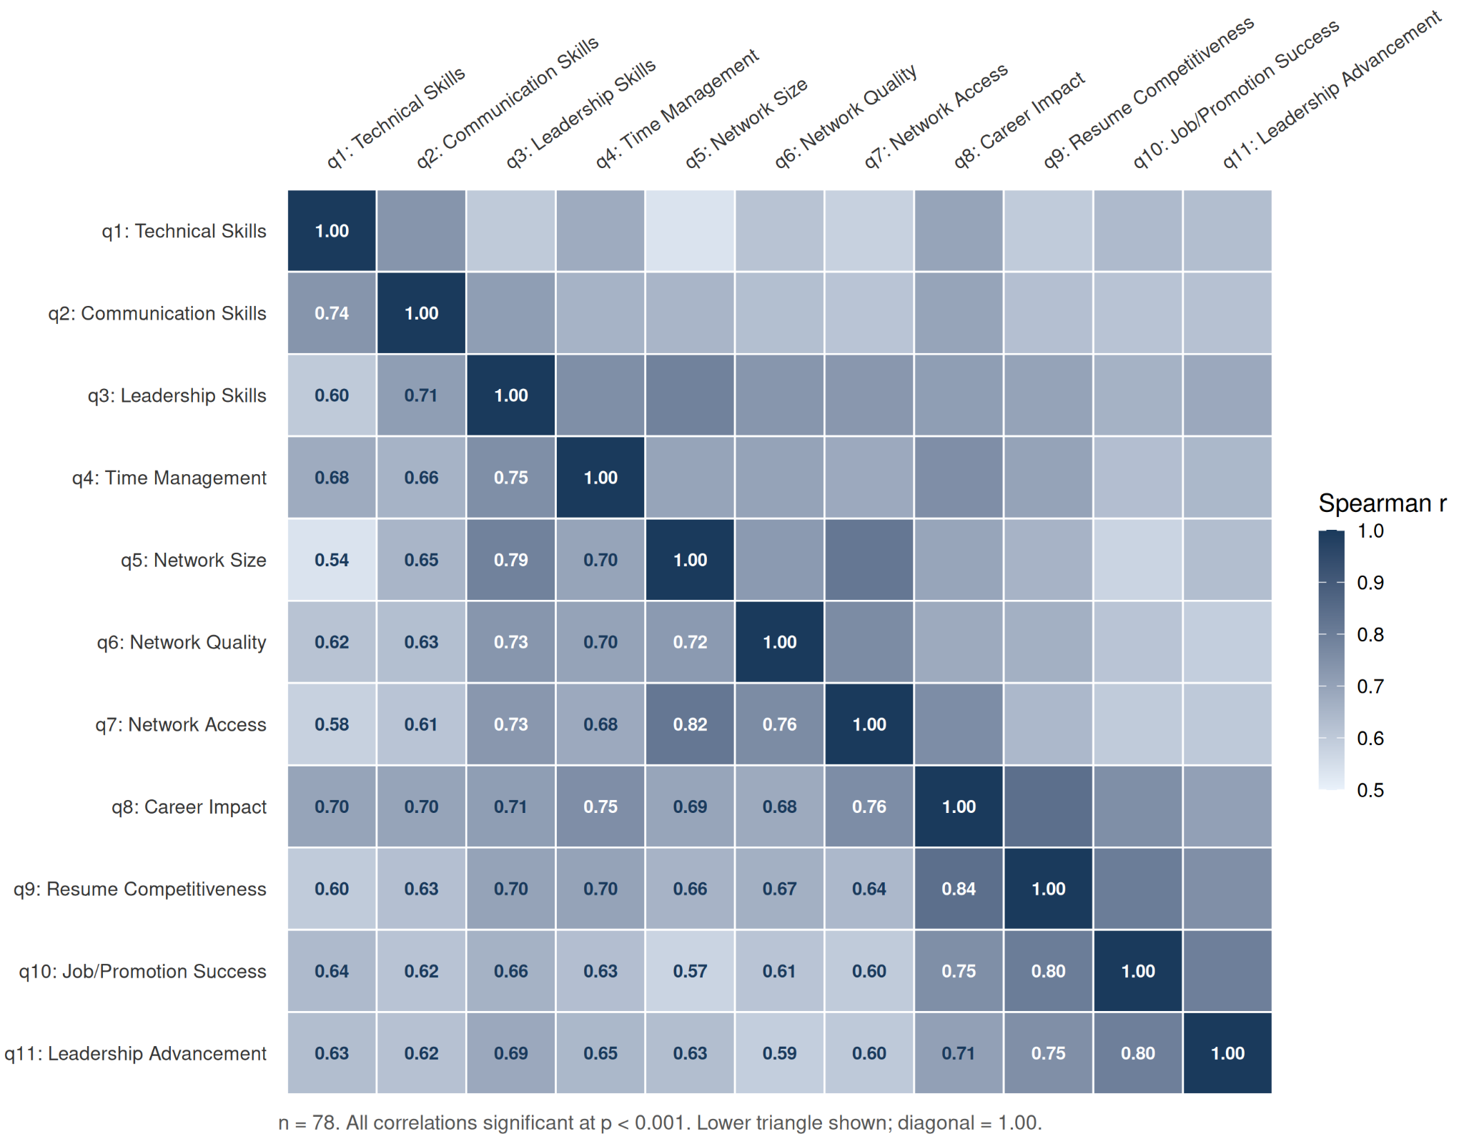
Note. n = 78. All correlations (r) are significant at p < .001. Lower triangle shown; diagonal = 1.00

Figure 2 Structural Equation Model of Skill Development, Networking, and Career Outcomes
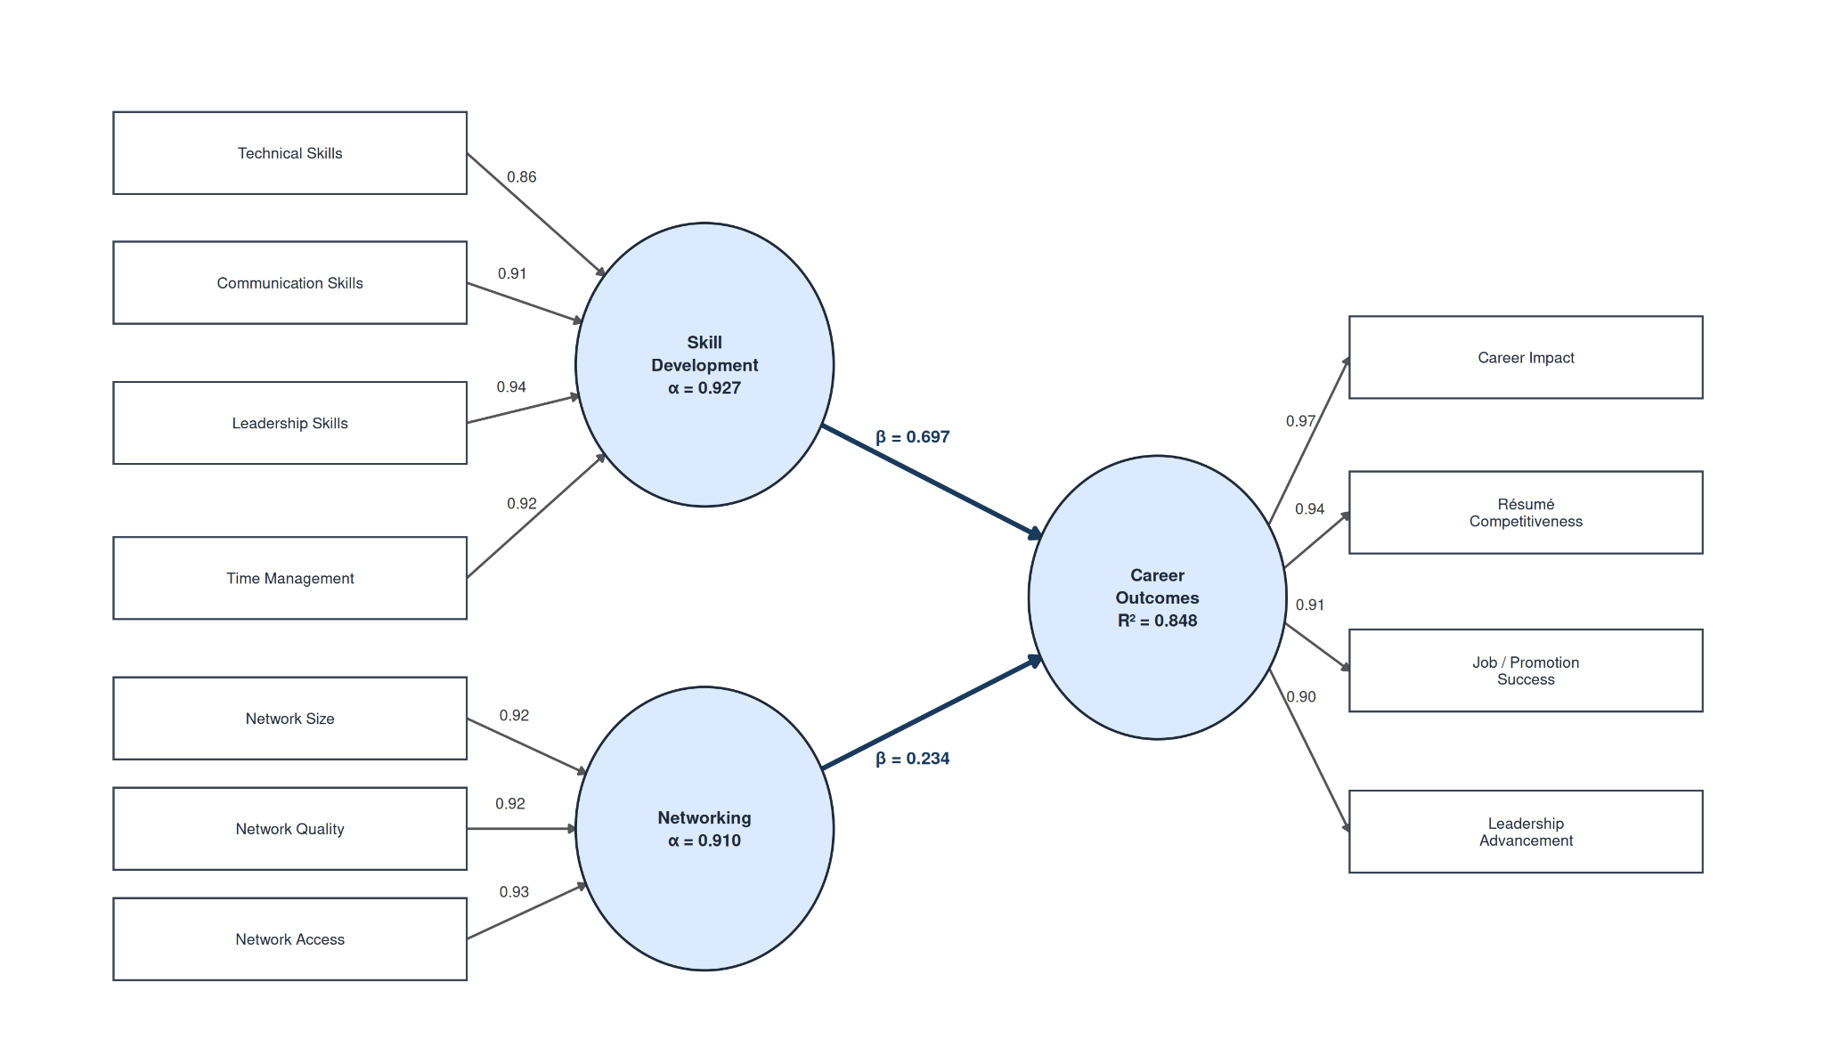
Note. Standardized structural equation model (WLSMV, ordered indicators) showing measurement loadings and structural paths among Skill Development, Networking, and Career Outcomes (n = 78 complete cases). Values on arrows are standardized coefficients.

Figure 3 Relative Importance of Predictors with Bootstrap Confidence Intervals
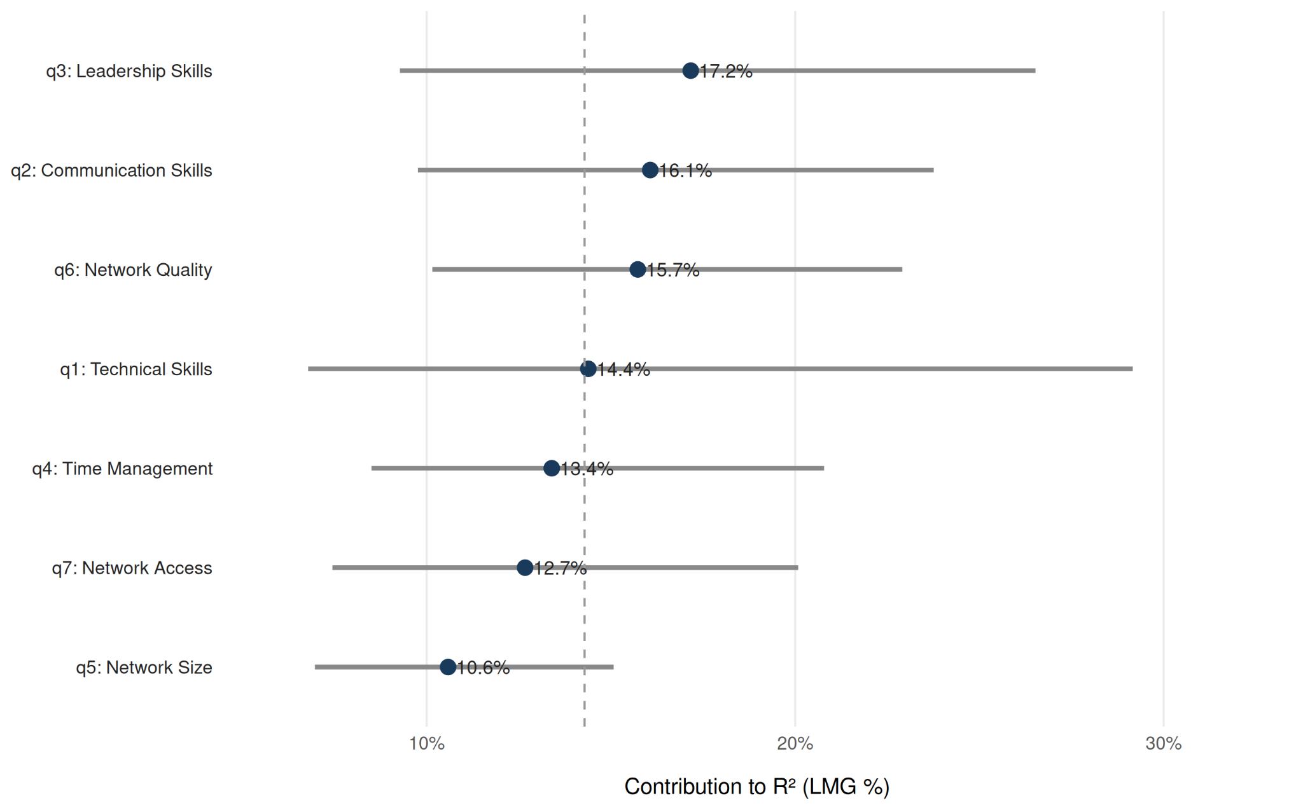
Note. Relative importance of predictors for job/promotion success using Lindeman-Merenda-Gold decomposition of model R² (n = 78; R² = .575). Points denote LMG estimates and horizontal bars show 95% bootstrap confidence intervals (1,000 resamples); dashed vertical line indicates equal-share baseline (14.3%).

Figure 4 Relative Importance of Skill and Network Predictors for Career Outcomes by Subgroup
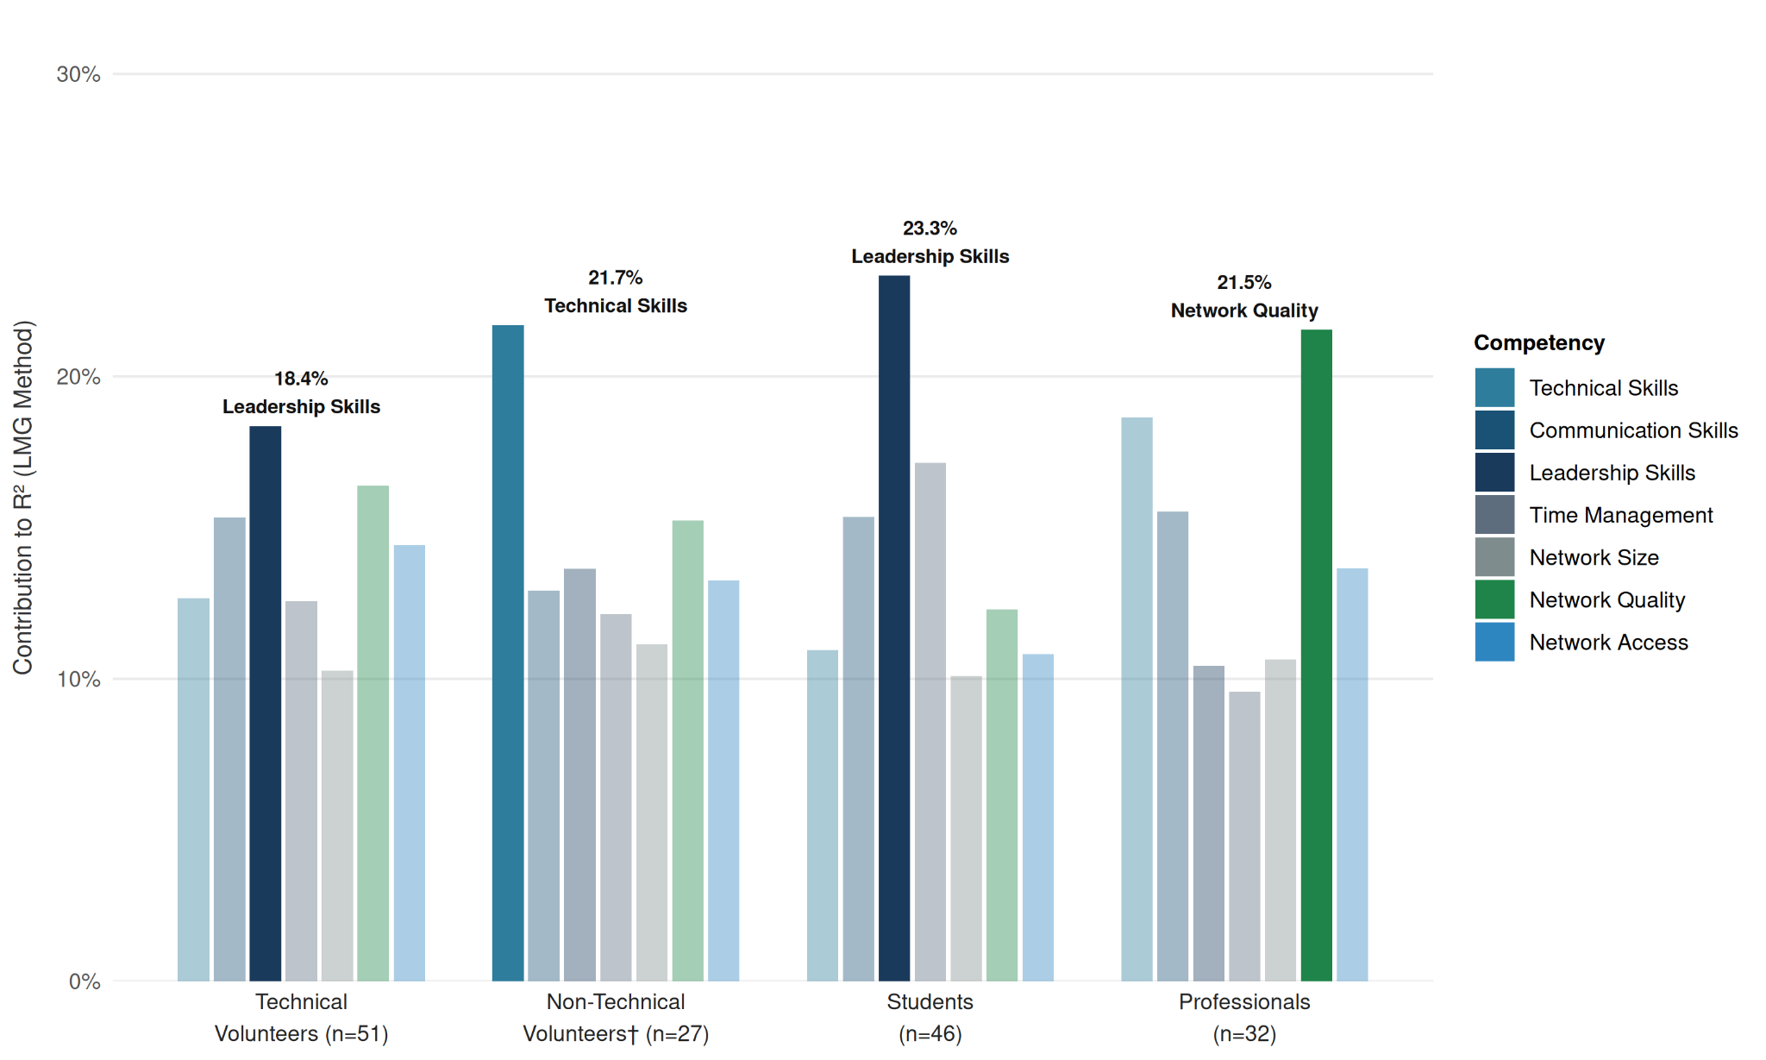
Note. Bars show each competency's LMG contribution (percentage of R²) estimated separately within four subgroups stratified by volunteer role (Technical, Non-Technical) and career stage (Student, Professional). The top-contributing predictor in each subgroup is highlighted at full opacity and labeled. LMG = Lindeman-Merenda-Gold relative importance decomposition. † Subgroup is exploratory (n < 30); interpret with caution.

Appendix A: Survey Questionnaire
Survey Title: [Organization] Volunteer Career Outcomes Survey

Section 1 of 2: Consent Form
This survey is conducted as part of [Organization]’s impact research initiatives and [First Author]’s doctoral dissertation at the [University Name]. Your participation is entirely voluntary and all responses will remain fully anonymous with no identifying information collected. Your anonymous survey responses may be analyzed, aggregated, and included in academic publications. By selecting “I agree and wish to participate” below, I affirm that I am providing my informed consent for my anonymous data to be used for these research and reporting purposes.
- I agree and wish to participate
- I do not wish to participate
Section 2 of 2: Survey
- What was/were your age group(s) while volunteering at [Organization]? (Select all that apply)
  - Options:
    - 10-14
    - 15-18
    - 19-22
    - 23-29
    - 30-39
    - 40-49
    - 50-59
    - 60-69
    - 70-79
    - 80+
    - Prefer not to say
    - Other…
2. Which of the following best describes your career stage when you volunteered with
[Organization]? (Select all that apply)
  - Options:
    - Middle school student
    - High school student
    - Undergraduate student
    - Master’s student
    - Doctoral student
    - Professional (0-3 years experience)
    - Professional (4-6 years experience)
    - Professional (7-10 years experience)
    - Professional (11-20 years experience)
    - Professional (21-30 years experience)
    - Professional (30+ years experience)
    - Retired
    - Prefer not to say
    - Other…
3. What were your countries of residence while volunteering at [Organization]? (Select all
that apply)
  - Options:
    - Argentina
    - Brazil
    - Colombia
    - India
    - Japan
    - Pakistan
    - United Arab Emirates (UAE)
    - United Kingdom (UK)
    - United States (USA)
    - Other…
4. What best describes your role at [Organization]? (Select all that apply)
  - Options:
    - App Development
    - Cloud Engineering / IT
    - ML Engineering
    - Web Development
    - Business Development
    - Grant Writing / Research
    - HR
    - Legal
    - Marketing
    - Operations
    - Other…
5. How long have you volunteered/did you volunteer for [Organization]?
  - Options:
    - Less than 3 months
    - 3-6 months
    - 6-12 months
    - 1-2 years
    - 2-3 years
    - 4-5 years
    - 5+ years
6. Volunteering at [Organization] improved my technical skills (e.g., programming, data
analysis, specific software).
  - Scale: Strongly disagree, 1, 2, 3, 4, 5, Strongly agree
7. Volunteering at [Organization] improved my communication skills (e.g., writing,
presentation, proposals, verbal).
  - Scale: Strongly disagree, 1, 2, 3, 4, 5, Strongly agree
8. Volunteering at [Organization] helped me cultivate stronger leadership skills (e.g., guiding
a team, decision-making).
  - Scale: Strongly disagree, 1, 2, 3, 4, 5, Strongly agree
9. Volunteering at [Organization] improved my time management and organizational skills
(e.g., meeting deadlines, prioritizing tasks, project planning).
  - Scale: Strongly disagree, 1, 2, 3, 4, 5, Strongly agree
10. My involvement with [Organization] led me to establish a larger number of professional
connections.
  - Scale: Strongly disagree, 1, 2, 3, 4, 5, Strongly agree
11. My involvement with [Organization] provided me with new professional insights, advice,
or learning opportunities.
  - Scale: Strongly disagree, 1, 2, 3, 4, 5, Strongly agree
12. My involvement with [Organization] gave me access to valuable professional circles or
communities.
  - Scale: Strongly disagree, 1, 2, 3, 4, 5, Strongly agree
13. My [Organization] experience positively impacted my overall career and academic
development.
  - Scale: Strongly disagree, 1, 2, 3, 4, 5, Strongly agree
14. My [Organization] experience made my resume/CV and LinkedIn profile more competitive
for job or academic applications.
  - Scale: Strongly disagree, 1, 2, 3, 4, 5, Strongly agree
15. My [Organization] experience provided skills that helped me secure a new job, promotion,
or academic placement.
  - Scale: Strongly disagree, 1, 2, 3, 4, 5, Strongly agree
16. My [Organization] experience helped me advance to roles with greater responsibility or
leadership.
  - Scale: Strongly disagree, 1, 2, 3, 4, 5, Strongly agree
17. Compared to before you joined [Organization], to what extent do you feel your
professional skills and network have grown?
  - Scale: No growth at all, 1, 2, 3, 4, 5, Transformational growth
18. Did your time at [Organization] contribute to your development of technical or soft skills?
If so, please describe which ones.
  - (Open text field)
19. Did [Organization] contribute to building your professional network? If so, please describe
how.
  - (Open text field)
20. Did your experience at [Organization] contribute to your search for a new job, internship,
or academic program (e.g., graduate school)? If so, please describe how.
  - (Open text field)

Appendix B: Thematic Analysis Codebook
This codebook outlines the final six themes developed through an inductive thematic analysis of open-ended survey responses, following the framework by Braun & Clarke (2006). Each theme is presented with its definition, the sub-codes that constitute it, and an illustrative quote from the survey data that exemplifies the theme.
Theme | Definition | Sub-codes | Illustrative Quotes
Interpersonal & Communication Development | Development of communication, teamwork, and cross-cultural collaboration skills required for coordination within globally distributed volunteer teams. | Communicational skills;  Cross-cultural collaboration skills | “Communication was also a key takeaway. Many people worked on different days and timezones, so finding the overlap between us was necessary and communicating all knowledge to the team was crucial especially in remote settings.”
Technical Skill Acquisition | Growth in technical competencies, including software tools, machine learning, cloud infrastructure, and applied digital workflows. | Familiarity/skills with AI;  Familiarity with AWS;  Familiarity with digital apps/software | “I gained practical experience in applied signal processing, machine learning evaluation, and interdisciplinary research”
Professional Network Expansion | Formation of new professional relationships and connections across industries, disciplines, and geographic regions through project collaboration. | Allowed network expansion with more senior professionals | “I was able to network with and receive advice from a diverse group of professionals, including doctors from the Ministry of Health, Labour and Welfare, CEOs of various companies, employees at Google, and alumni from top-tier universities.”
Career Signaling & Marketability | Ability to translate volunteer experience into résumé credentials, interview narratives, references, and demonstrable professional competence. | Boosted resume;  Material to discuss during interviews | “I always mention [Organization] when I am at clinical trials and also, when volunteering at tech conferences as part of my icebreaker and elevator pitch.”
Leadership & Ownership Development | Experience assuming responsibility for tasks, coordinating team efforts, and exercising initiative within project-based volunteer work. | Leadership skills;  Improved initiative;  Organizational skills;  Personal confidence | “I developed a strong sense of ownership over my tasks and learned the importance of proactive communication in a volunteer team.”
Career Identity Clarification | Increased clarity regarding career interests, preferred professional environments, and long-term educational or occupational goals. | Refined future career goals | “It gave me a sense of what kind of company and team I would want to work for moving forward. It gave me clarity on the kind of impact I want to have.”

